**Paper Title (16 Bold)**

Author (14)

*Mechanical Dept., Faculty of Industrial Education, Suez University, Suez, EGYPT*

*Corresponding Author: xxxx .(10)*

***ABSTRACT:* (10 Bold)** *This paper presents the experimental a solar desalination system based on humidification dehumidification (HDH). Is exploited for the desalination purpose. The solar desalination process is currently operating under the climatological conditions of Suez city, Egypt 29.9668°N, 32.5498°E .an experimental setup has been designed, constructed and assembled. A set of experimental runs have been carried out throughout this study. As a result of this work, the tests were done from September to October 2016.The effects of spherical dome height and mass flow rate of hot saline water on fresh water productivity were monitored. The results show that; the spherical dome height 40 cm has more productivities than others.The hot saline water 3.02 kg/ min has high values of productivity than others. The system productivity is (2.68L/m2),the estimated cost is (0.12$/L) and the efficiency is 61%.*

**NOMENCLATURE (10 Bold)**

|  |  |  |
| --- | --- | --- |
| **Symbol** | **Description** | **Unit** |
| *A* | Area | *m2* |
| *h* | Enthalpy | *J/ ${kg}_{dry air}$* |
| *hfg* | Latent heat of vaporization | J/kg |
| *I* | Solar intensity | *W/ m2* |
| i | Accurrent | Amb |
|  | Mass flow rate | *kg/s* |
| p | Pressure | bar |
| S | Salinity | ppm |
| *T* | Temperature | *o C* |
| *U* | Uncertainty |  |

**Greek letter**

|  |  |  |
| --- | --- | --- |
| η | Efficiency |  |

**Subscripts**

|  |  |
| --- | --- |
| ct | Collectors (evacuated ) |
| f | Fresh water |
|  | Fluid-gas |
|  | Pumping |

**--------------------------------------------------------------------------------------------------------------------------------------**

Date of Submission: xx-xx-xxxx Date of acceptance: xx-xx-xxxx

**--------------------------------------------------------------------------------------------------------------------------------------**

1. **INTRODUCTION (10 Bold)**

Desalination is a water-treatment process that separates salt from saline water to produce potable water or water that is low in total dissolved solids; many countries in the world suffer from a shortage of natural fresh water. Increasing amounts of fresh water will be required in the future as a result of the rise in population rates and enhanced living standards, together with the expansion of industrial and agricultural activities, Thermal solar energy is considered to be one of the most promising applications of renewable energies to seawater desalination, as it is suitable for arid and sunny regions. A thermal solar distillation system usually consists of two main parts, the collecting device and the distiller. Solar thermal desalination processes are characterized to be direct processes when all parts are integrated into one system, while the case of indirect processes refers to the heat coming from a separate solar collecting device, usually solar collectors or solar ponds. The review of some of previous work related to {Solar Water Distillation Techniques [1-4], Humidification dehumidification [5-19], Spherical dome [21-24]}.

Review of solar distillation methods were discussed by Patel et al., [1]. Many various methods were developed by the researchers to distil the brackish water. It were founded that various methods developed for distillation of water. These methods were subjected to request of fresh water, quality of water and the cost. The multi-effect distillation method can be used for mass production of fresh waterOpportunities for solar water desalination worldwide was provided by Shatat et al., [2] the thermal desalination method is now used for desalination of seawater in oil rich countries and the reverse osmosis method becomes the second technology on a global scale.Sivakumar and Sundaram [3] were provided Improvement techniques of solar still efficiency. Many research works done on solar still to improve its productivity were reviewed. and The main points are: ( heat storing procedure in solar desalination process were effective than that without heat storage; By the introduction of baffle suspended absorber plate the free surface area of water was increased which gives 18.5–20% more productivity.Sharon and Reddy [4] presented a review of solar energy driven desalination technologies. It was found that solar energy driven desalination units can decrease carbon emissions and can supply desalinated water in a sustainable way.Modeling of a solar driven HD (Humidification-Dehumidification) desalination system it had studied by Franchini andPerdichizzi[5].A solar driven HD desalination system has been investigated in the present study. Two different configurations have been compared: an integrated solar cooling and desalination system and separated solar cooling and solar desalination units.Zamen etal.,[6].It had presented Experimental investigation of a two-stage solar humidification–dehumidification desalination process.The multi-stage HD process for desalination was introduced. Theoretical results show that important parameters of the process such as specific energy consumption, productivity and daily production per solar collector area improved when multi-stage process was used instead of single-stage process.Humidification compression desalination discussed byGhalavandetal.,[7].A new technology is investigated in this study and compared with two conventional HDH methods under similar operating conditions. The proposed method has higher water production, higher water recovery and lower energy consumption in comparison with the two othermethods.Kabeel and El-Said investigated A hybrid solar desalination system of air humidification,dehumidification and water flashing evaporation: Part II.Experimental investigation,[8].an experimental investigation of a solar hybrid desalination system consisting of HDH unit and single stage flashing evaporation unitwas presented. The experimental results show that freshwater production increases with solar radiation. Xing Li et al., provided Experimental study on a humidification and dehumidificationdesalination system of solar air heater with evacuated tubes [9].a new kind of solar air heater is developed and tested. The solar air heater shows good thermal performance in the experimental process with higher insulation and sealing property. With the theoretical analysis of heating and humidifying processes.YıldırımandSolmus were studied A parametric study on a humidification–dehumidification (HDH)desalination unit powered by solar air and water heaters [10].A theoretical study is conducted to investigate the effects of the various operating and design parameters.Experimental study for hybrid humidification–dehumidification waterdesalination and air conditioning system had presented by nada et al., [11].Experimental study for investigating humidification–dehumidification water desalination and air conditioning system using vapor compression refrigeration cycle has been carried out.Elminshawy et al., discussed Experimental and analytical study on productivity augmentation of anovel solar humidification–dehumidification (HDH) system.[12].It had explained and emphasized the great importance and benefits of using flat external reflector, immersion water heaters and induced atmospheric air that boosts the evaporation rate.Energy and exergy analysis for a humidification–dehumidificationdesalination system integrated with multiple inserts investigated by Muthusamy and Srithar.[13]. The performance enhancement of HDH desalination is made by inserting three types of inserts in the air heater, two types of packing materials in the humidifier namely gunny bag and saw dust and also spring insert in the dehumidifier. Performanceinvestigation of a novel water–power cogeneration plant(WPCP) based on humidification dehumidification (HDH) method provided by He et al., [14]. Based on the proposed mathematic models for the novel water– power cogeneration plant, the corresponding performance investigation at different prescribed parameters is achieved.Experimental investigation of a multi-effect isothermalheat with tandem solar desalination system based onhumidification–dehumidification processes had studied by Wu et al., [15]. It was presented a multi-effect isothermal heat with tandem desalination system based on humidification–dehumidification process and itsworking principle has been described.Giwa et al., presented Recentadvancesinhumidification dehumidification (HDH) desalination processes:Improveddesignsandproductivity [16]. It had found that the HDH desalination process is a promising technique for producing fresh water to meetlocalized water demand.Humidification–dehumidification desalination process driven byphotovoltaic thermal energy recovery (PV-HDH) for small-scalesustainable water and power production it was discussed by Giwa et al., [17].A detailed study of PV-HDH as a sustainable desalinationmethod has been carried out. Sharshir et al., investigated a continuous desalination system using humidification –dehumidification and a solar still with an evacuated solar water heater. [18]. Performances of a continuous solar desalination system consisting of HDH unit and SS have been studied. It was noticed that small HDH unit or SS unit individually is not efficient for desalination of brackish water and seawater.Behnam and Shafii had provided Examination of a solar desalination system equipped with an air bubblecolumn humidifier, evacuated tube collectors and thermosyphonheat pipes. [19].The performance of a novel HDH system equipped with an air bubble column humidifier, evacuated tube collectors, and heat pipes was studied experimentally.Arunkumar et al., discussed an experimental study on a hemispherical solar still. [21]. A hemispherical solar still has been fabricated and tested with and without top cover cooling. The efficiency was increased from 34% to 42% for a fixed flow rate of 10 ml/min of water fed. Experimental study on various solar Still designsit had investigated by Arunkumar et al., [22]. The fabrication of seven solar still designs (spherical, pyramidal, hemispherical, double basin, concentrator-coupled CPC tubular, CPC coupled with pyramid solar still) and their performance evaluation in converting brackish water into fresh water for drinking are presented. It had performance analysis of hemispherical solar still in climate condition ofMEHSANA, GUJARAT. It had provided by Panchal et al., [23]. a new transportable hemispherical solar still was designed, fabricated and experimentally tested during daytime for one day under outdoors of summer climatic conditions.Comparative Study on Hemispherical Solar Still with Black Ink Added. It had studied by Solanki et al., [24]. It had concluded that the productivity of the hemispherical was increases due to decrease in water depth.

From previous review,the present study aims to experimentally investigate the solar water distillation characteristics of spherical dome as a dehumidifier surface. Parameters that can be used to measure the performance of this type of solar water distillation are also presented, investigated and estimated. The effects of some geometric parameters of the spherical dome on the performance of the solar water distillation will be investigated. The experiments have been carried out to provide comprehensive study of the solar water distillation by using spherical dome as a dehumidifier surface at different key design parameter.

1. **EXPERIMENTAL SETUP (10 Bold)**

The experimental setup consists mainly of three parts; humidifier-dehumidifier section, saline water cycle, and cooling water cycle as shown in Fig. 1.The humidifier-dehumidifier tank was manufactured from steel. It consists of built in double tank; the outer tank has 80 cm diameter and 200 cm length and the inner tank has 60 cm diameter and 170 cm length. The gap between double tanks to collect the fresh water condensate, the hot saline water pressured in the nozzles in the inner tank to evaporate, also, then the cold spherical dome condensate the fresh vapor and drag to collect it as a water drop on the inner surface of the spherical dome to collect it in the gap.The non-evaporated saline returns back to level controlled tank to pressure it to the collector.

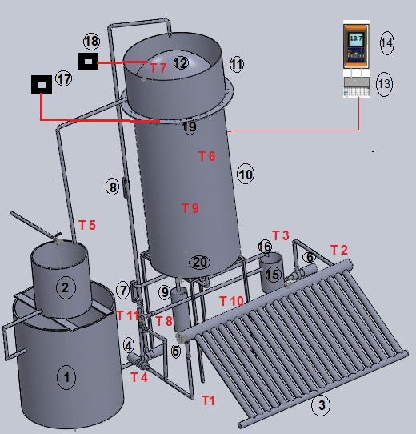

**Fig. 1 Experimental setup scheme**

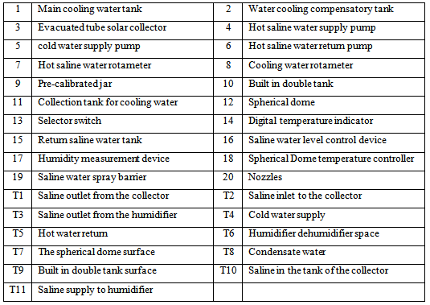

Six similar nozzles were fixed on 0.5 inch tube 40 cm diameter as shown in Fig. 2. The humidifier-dehumidifier section was insulated at its outside surface by glass wool layer of 5.0 cm thickness except the top surface; it's connected to cold water cycle to keep the surface temperature at 40 o C to enhance the condensate the vapor as shown in Fig. 3.

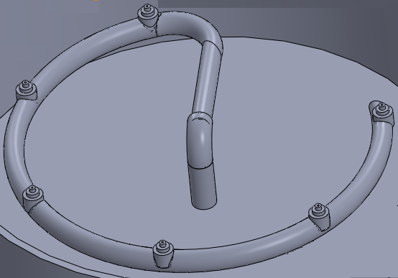

**Fig. 2Six similar nozzles were fixed on 0.5 inch tube 40 cm diameter**

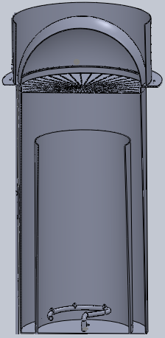

**Fig. 3 Humidifier-dehumidifier section (10 Bold)**

The nozzle has outside diameter of 15 mm, inner diameter of 9 mm, 30 mm length, tapered into end top diameter of 10 mm and the orifice diameter 1.0 mm as shown in Fig. 4. The evacuated tube solar collector has a storage tank of 200.0 L volume, surface area is 3.0 m2, and its inclination angle is 250. The hot water from the collector was pumped by a pump having a power of 375.0 W .The water flow rate was measured using a rotameter having a range from 0.2 L/min. to 4.9 L/min . With a repeatability error of about 0.5% . A digital temperature indicator (Manufacturer: BK PRECISION, Model: 710, K-type) with 0.1 °C resolution was used to record the temperature which sensed by K-type thermocouple. Temperature measurements were recorded at eleven locations; saline inlet to the collector, saline in the tank of the collector, saline outlet from the collector, saline supply to humidifier, humidifier dehumidifier space, saline outlet from the humidifier, condensate water, water supply to cold the spherical dome, hot water exit after cooling the spherical dome surface to the tank, the spherical dome surface, built in double tank surface, as shown in Fig. 1. A hygrometer having a range (0.0–100%) with an accuracy of ±1% was used to measure the relative humidity. The flow rate of fresh water was measured by a pre-calibrated measuring jar having a range of (0.0 – 3 L) volume with an accuracy of 0.01 L. A solar power meter having a range (0.0– 1999 W/m2) with an accuracy of ±10 W/m2 was used to measure the solar radiation. Referring to Fig. 5, to get the electric power consumption to drive the motors of pumps, a voltmeter has a range of (0.0–750 V) with an accuracy of ±0.1 V was used to measure the voltage. An ammeter has a range of (0.0–20 A) with an accuracy of ±0.01 A was used to measure the current. The measurements were daily recorded from 8.0 am to 5.0 pm at an equal internal of one hour.



**Fig. 4 Nozzle scheme**

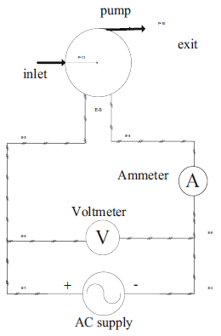

**Fig. 5 Electrical circuit of pumps**

1. **RESULTS AND DISCUSSION (10 Bold)**

In the presentexperimental work, the following working parameterswere considered:The mass flow rate of hot saline water and the effect of the spherical dome curvature on fresh water productivity versus the day time (8.0 am – 5.0 pm),With reference to Fig.6, one can find that the increase in the intensity of the sun leads to an increase in fresh water productivity at the same time and the same dome is equal to 10 cm. This is due to the increase in the temperature of salts that cause more evaporation of salt water and increase the flow rate of mass of salt water, and as a result, productivity increases. Also, in Fig.7 and Fig.8, the productivity of fresh water was observed at the same time and the same height dome 18 cm and 40 cm respectively,



**Fig. 6 Fresh water productivity versus day time at spherical dome height 10 cm**



**Fig. 7Fresh water productivity versus day time at spherical dome height 18 cm**



**Fig. 8Fresh water productivity versus day time at spherical dome height 40 cm**

The variation of productivity versus day time at different solar intensities at constant Spherical dome heights 10, 18 and 40 as shows in figures 9, 10 and 11 respectively.

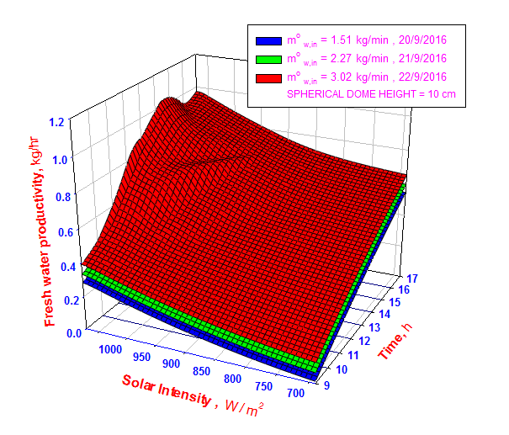

**Fig. 93-D, variation of productivity versus day time at different solar intensities at Spherical dome height10 cm**

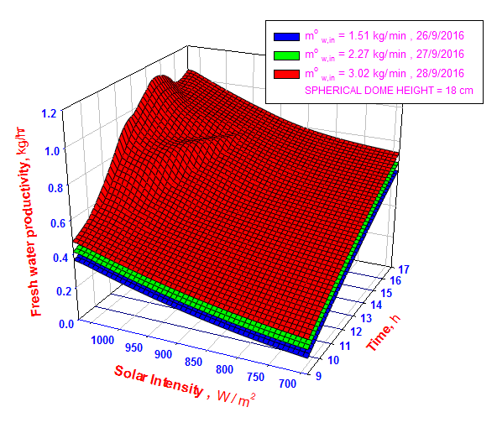

**Fig. 103-D, variation of productivity versus day time at different solar intensities at Spherical dome height18 cm**

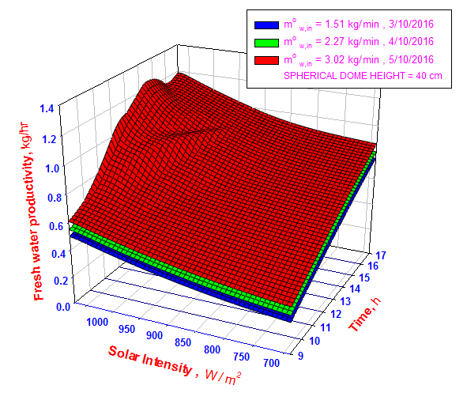

**Fig. 113-D, variation of productivity versus day time at different solar intensities at Spherical dome height 40 cm**

Figures12, 13 and 14 shows a comparison between fresh water production versus day time at the same flow rate and different height of the spherical dome, That's shows that The effect of fresh water productivity, increase, during the afternoon. also, the surface area of the spherical dome 10, 18 and 40 leads to an increase in fresh water productivity. and it's shows that the spherical dome with height 40 is larger than the others in productivity.



**Fig. 12Fresh water productivity versus day time at flow rate 1.51 kg/min**



**Fig. 13Fresh water productivity versus day time at flow rate 2.72 kg/min**



**Fig. 14Fresh water productivity versus day time at flow rate 3.02 kg/min**

The variation of productivity versus day time at different solar intensities at same flow rate at the height of a spherical dome 10, 18 and 40 in Figs. 15, 16 and 17, respectively.

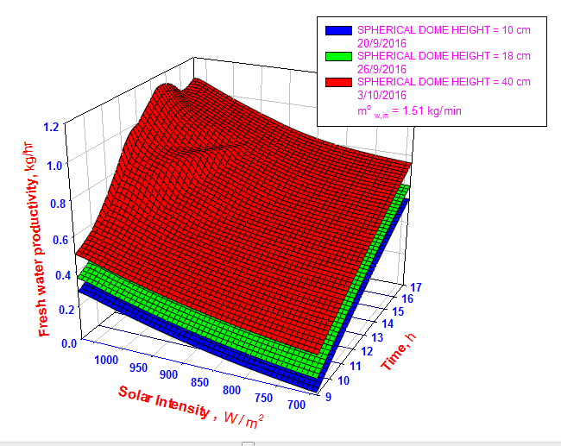

**Fig. 153-D, variation of productivity versus day time at different solar intensities at flow rate 1.51 kg/min**

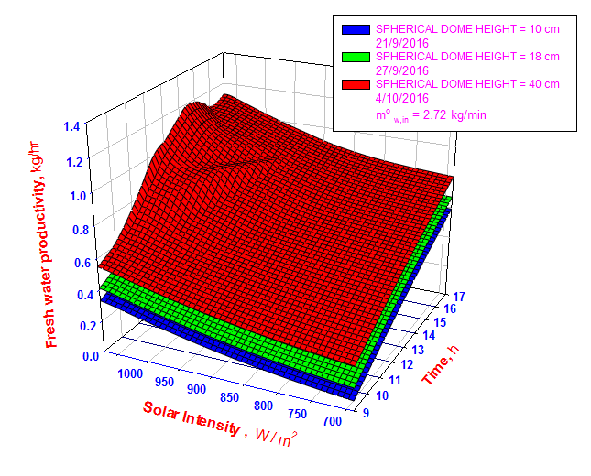

**Fig. 163-D, variation of productivity versus day time at different solar intensities at flow rate 2.72 kg/min**

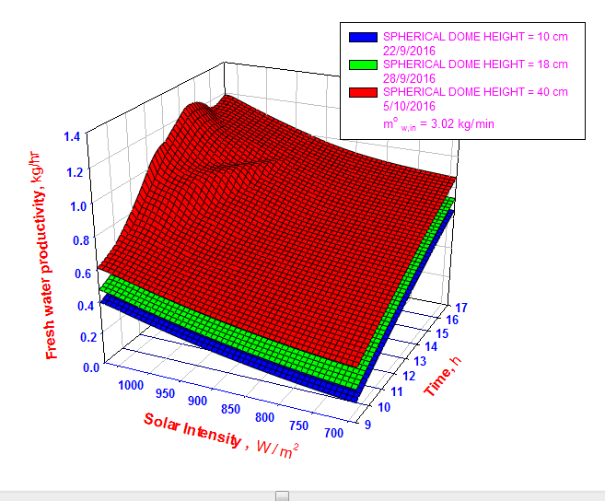

**Fig. 173-D, variation of productivity versus day time at different solar intensities at flow rate 3.02 kg/min**

**UNCERTAINTY ANALYSIS**

The efficiency of the tested system can be determined as following:

$=\frac{m_{f}^{o}*h_{fg}}{((I*A_{ct})+{\left(i*v\right)}_{p})}$ =0.61(1)

The uncertainty of the collector’s area can be determined as the following sequence:

$A_{ct}=L*W$ (2)

$\frac{∂A_{ct}}{∂L}=W$ (3)

$$\frac{∂A_{ct}}{∂W}=L$$

ΔA = = 4.2*10-3 m2  (4)

= 0.33( (5)

= 1.53*10-4( (6)

= -2.56*10-4( (7)

= - 0.09((8)

= - 0.056((9)

= - 4.35*10-4 ( (10)

Δ =

= 3.466*10-3  (11)

U= = =5.68*10-3  (12)

**COST AND EFFICIENCY**

The cost per unit volume fresh water productivitymay be determined as provided by [20]. The cost assessment neglect the power required for driving the pump and it was assumed that a photo voltaic unit will be existed for electricity production required for pumping power. As provided by [20]. In the present work, AC supply was actually used for driving the electric motors for all the pumps. So the specific cost of fresh water productivity will be as follows:

Cost per litter= $\frac{Total capital cost +[{\left(iv\right)}_{P}*Total operation time*\left(\frac{Price}{\left(Kw hr\right)}\right)]}{Annual fresh water total*life time}$ (13)

Referring to Table 1the capital costs of the system items are existed. The total capital cost is 4765 $. The cost ofelectric power required for driving the pump and blower can be estimated as following:

${\left(iv\right)}_{P}*Total operation time*\left(\frac{Price}{\left(Kw hr\right)}\right)$ = $\frac{3*1.1 Amb*250 volt*9 hr*365 day*20 year*0.0375\$/\left(Kw hr\right)}{1000}$ = 2032.6 $(14)

Thus; the cost per unit litter productivity is 0.12 $/L, for a life time of 20 years.The maximum efficiency was 61% as shown in Fig. 18.

**Fig. 18 Time variation of thesystem efficiencyandproductivity**

**Table(1). Prices of system individual units.**

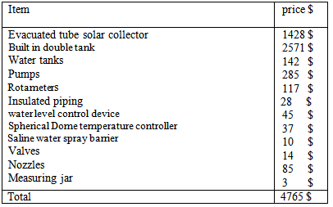

**COMPARISON AMONG PRESENT WORK AND PREVIOUS WORKS**

The comparison shows somehow a satisfactory and agreement among the present work and previous ones as shown in Fig. 19, For Deniz, [26]; the productivities are less than the present work. Deniz, [26] used lower values of saline flow rates. For Tabrizi, [25] and Eldesouki, [21]; the productivities are higher than the present work. Tabrizi, [25] system depends on natural circulation without pumping. Eldesouki, [21] system was based on a free jet-humidification with an auxiliary perpendicular hot air stream was carried out at Suez city, Egypt



**Fig. 19 Comparison among the present work and previous ones**

1. **CONCLUSION (10 Bold)**

A solar desalination system based on free jet-humidification with an auxiliary cold water system was carried out at Suez city, Egypt 29.9668°N, 32.5498°E. The main conclusions items can be briefly systemized as the following:

1. Spherical dome heights 40 cm produce the highest fresh water productivity at the same condition.
2. Increase the condensation surface will be increase the fresh water productivity
3. Increase the salinemass flow rate will be increase the fresh water productivity
4. The system productivity is (2.68 L/m2), the estimated cost is (0.12 *$/L*) and the efficiency is 61 %.

**REFRENCES (10 Bold)**

1. Patel, H., Patel, P. and Patel, J. [2012] “Review of solar distillation methods” International Journal of Advanced Engineering Research and Studies, Vol. II, Issue I: pp.157–161.
2. Shatat, M., Worall, M. and Riffat, S. [2013] “Opportunities for solar water desalination worldwide: Review” Sustainable Cities and Society, Vol. 9: pp.67–80.
3. Sivakumar, V. and Sundaram, E. G. [2013] “Improvement techniques of solar still efficiency: A review” Renewable and Sustainable Energy Reviews, Vol. 28: pp.246–264.
4. Sharon, H. and Reddy, K. S. [2015] “A review of solar energy driven desalination technologies” Renewable and Sustainable Energy Reviews, Vol. 41: pp.1080–1118.
5. Franchini, G. and Perdichizzi, A. [2014] “Modeling of a solar driven HD (Humidification-Dehumidification) desalination system” Energy Procedia, Vol. 45: pp.588–597.
6. Zamen, M., Soufari, S. M., AbbasianVahdat, S., Amidpour, M., Zeinali, M. A., Izanloo, H. and Aghababaie, H. [2014] “Experimental investigation of a two-stage solar humidification–dehumidification desalination process” Desalination, Vol. 332: pp.1–6.
7. Ghalavand, Y., Hatamipour, M. S. and Rahimi, A. [2014] “Humidification compression desalination” Desalination, Vol. 341: pp.120–125.
8. Kabeel, A. E. and El-said, E. M. S. [2014] “A hybrid solar desalination system of air humidification, dehumidification and water flashing evaporation: II. Experimental investigation” Desalination, Vol. 341: pp.50–60.
9. Li, X., Yuan, G., Wang, Z., Li, H. and Xu, Z. [2014] “Experimental study on a humidification and dehumidification desalination system of solar air heater with evacuated tubes” Desalination, Vol. 351: pp.1–8.
10. Yildirm, C. and Solmus, I. [2014] “A parametric study on a humidification–dehumidification (HDH) desalination unit powered by solar air and water heaters” Energy Conversion and Management, Vol. 86: pp.568–575.
11. Nada, S. A., Elattar, H. F. and Fouda, A. [2015] “Experimental study for hybrid humidification–dehumidification water desalination and air conditioning system” Desalination, Vol. 363: pp.112–125.
12. Elminshawy, N. A. S., Siddiqui, F. R. and Addas, M. F. [2015] “Experimental and analytical study on productivity augmentation of a novel solar humidification–dehumidification (HDH) system” Desalination, Vol. 365: pp.36–45.
13. Muthusamy, C. and Srithar, K. [2015] “Energy and exergy analysis for a humidification–dehumidification desalination system integrated with multiple inserts” Desalination, Vol. 367: pp.49–59.
14. He, W. F., Han, D., Xu, L. N., Yue, C. and Pu, W. H. [2016] “Performance investigation of a novel water–power cogeneration plant (WPCP) based on humidification dehumidification (HDH) method” Energy Conversion and Management, Vol. 110: pp.184–191.
15. Wu, G., Zheng, H., Kang, H., Yang, Y., Cheng, P. and Chang, Z. [2016] “Experimental investigation of a multi-effect isothermal heat with tandem solar desalination system based on humidification–dehumidification processes” Desalination, Vol. 378: pp.100–107.
16. Giwa, A., Akther, N., AlHousani, A., Haris, S. and Hasan, S. W. [2016] “Recent advances in humidification dehumidification (HDH) desalination processes: Improved designs and productivity” Renewable and Sustainable Energy Reviews, Vol. 57: pp.929–944.
17. Giwa, A., Fath, H. and Hasan, S. W. [2016] “Humidification–dehumidification desalination process driven by photovoltaic thermal energy recovery (PV-HDH) for small-scale sustainable water and power production” Desalination, Vol. 377: pp.163–171.
18. Sharshir, S. W., Peng, G., Yang, N., El-Samadony, M. O. A. and Kabeel, A. E. [2016] “A continuous desalination system using humidification – dehumidification and a solar still with an evacuated solar water heater” Applied Thermal Engineering, Vol. 104: pp.734–742.
19. Behnam, P. and Shafii, M. B. [2016] “Examination of a solar desalination system equipped with an air bubble column humidifier, evacuated tube collectors and thermo syphon heat pipes” Desalination, Vol. 397: pp. 30–37.
20. Eldesouki I., Reda A., Mohamed A. [2018] “An experimental study of solar desalination using free jets and an auxiliary hot air stream”Heat Mass Transfer, Vol. 54:[Issue 4](https://link.springer.com/journal/231/54/4/page/1), pp. 1177–1187.
21. Arunkumar, T., Jayaprakash, R., Denkenberger, D., Ahsan, A., Okundamiya, M. S., kumar, S., Tanaka, H. and Aybar, H. S. [2012] “An experimental study on a hemispherical solar still” Desalination, Vol. 286: pp.342-348.
22. Arunkumar, T., Vinothkumar, K., Ahsan, A., Jayaprakash, R. and Kumar, S. [2012] “Experimental Study on Various Solar Still Designs” International Scholarly Research Network ISRN Renewable Energy, Vol. 2012: Article ID 569381, 10 pages.
23. Panchal, H. N., Prajapati, V., Goswami, R. and Pancholi, N. [2012] “Performance analysis of hemispherical solar still in climate condition of Mehsana, Gujarat” International Journal of Advanced Engineering Research and Studies, Vol. I, Issue III: pp.210-213.
24. Solanki, A. S., Soni, U. R. and Patel, P. [2014] “Comparative Study on Hemispherical Solar Still with Black Ink Added” International Journal of Engineering Research and General Science, Vol. 2, Issue 3: pp.2091-2730.
25. Tabrizi FF, Khosravi M, Sani IS [2016]“Experimental study of a cascade solar still coupled with a humidification–dehumidification system” Energy Convers Manag,Vol.115:pp.80–88.
26. Deniz E, Cinar S [2016] Energy, exergy, economic and environmental (4E) analysis of a solar desalination system with humidification-dehumidification energy. Convers Manag, Vol.126: pp.12–19.